ACTIVITIES OF NSS FOR ACADEMIC YEAR 2018-19

- CELEBRATION OF YOGA DAY
The NSS Unit of Shailendra College had organized ‘Yoga Abhyas’ on account of International Yoga Day 2018 at the Principal D. G. Samant hall on 21st June 2018. More than 70 students and staff members participated in the event. The day is celebrated all over the world and is the symbol of rising importance of Yoga and its benefits for a healthy life. Members of ‘Shri Ambika Yog Kutir’ guided students and teachers in performing Pranayam and Yog asanas. The emphasis was on benefits of Yoga Practice for enhancing concentration of students and improving not just their physical but also mental and emotional fitness. It has definitely helped in generating awareness among the students and takes a step towards good health and well being.

- ORIENTATION OF THE STUDENTS 8TH AUGUST 2018
The Orientation of the students of the classes of F.Y.B.Com and F.Y.B.A. for understanding the National Service Scheme was held on 8th August 2018 in the Audio Visual Room. More than 120 students participated in the event. the Rules and Regulations of the NSS Unit were explained to them in details. A few students of S.Y.B.A. and T.Y.B.A. also expressed their thoughts and shared their experiences of the NSS. Principal Dr. Swati Pitale Madam emphasized on the importance of social service as a valuable addition to the Bio-data for entering into job market in their future. She also presented the NSS students with certificates for those volunteers who had participated in various workshops, competitions and camps at various intercollegiate and university level.

- LEPROSY SURVEY BY VOLUNTEERS WITH BMC R NORTH WARD
14 volunteers from our Unit participated in a joint activity with BMC R North Ward’s Health Department in a survey conducted at the grass root level for reporting of Leprosy patients in the area of Ambavadi. The activity was conducted for a fortnight from 24th September to 8th October 2018.

- CROWD MANAGEMENT AT GANESH VISARJAN SITE WITH DAHISAR POLICE SATION

Our students have regularly been associated with Dahisar Police Station for crowd management during the auspicious Ganesh festival. A total of 49 volunteers were deputed across dahisar areas and two artificaial visarjan points at Dahisar Sports oundation and Ashokvan. They were given certificates for the same by the Police Department.

- DANOTSAV- COLLECTION OF 9330/- RS AS DONATION FOR KERALA SCHOOLS ALONG WITH CHILD HELP FOUNDATION
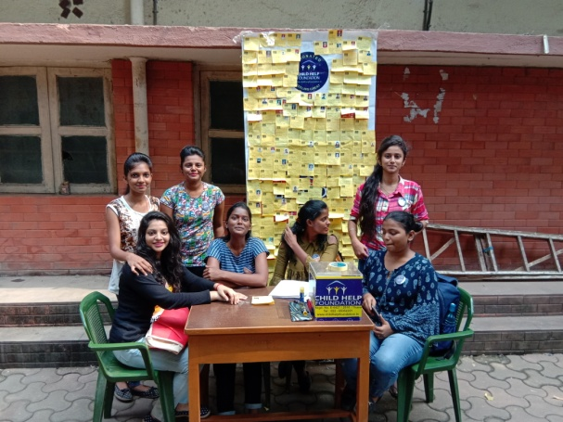

Danotsav is a national level event under Government of India for colllections of funds and donation for the Kerala relief activities. An NGO by the name Child Health Foundation had approached us for the ‘Buy a Brick’ project for the re-building the Government Schools in Kerala. Our volunteers were able to collect a total of Rs.9330/- for the same.

- COLLECTION OF DONATION FOR KERALA WITH INDIAN DEVELOPMENT FOUNDATION
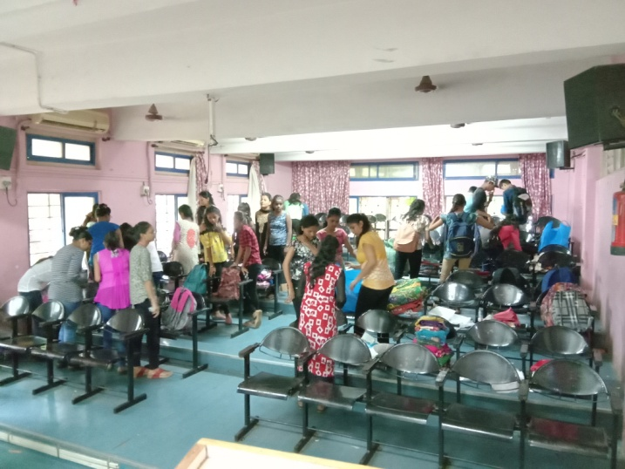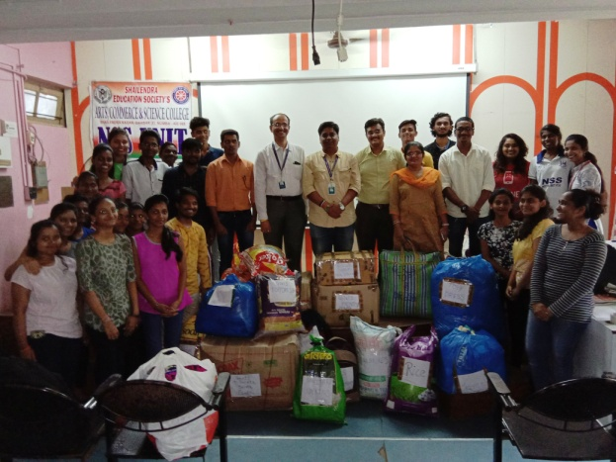
The NSS Unit along with Indian Development Foundation had collected more than 100Kg of Rice, 50Kg of Wheat, Biscuits, Clothes and other things of daily needs to Kerala and sent it through a special truck to Kerala within a week of the natural disaster. The students got such an overwhelming response from the people for the same.

- NATURE TRAIL AND CLEANLINESS DRIVE AT SANJAY GANDHI NATIONAL PARK BORIVALI ON 18TH AUGUST 2018.

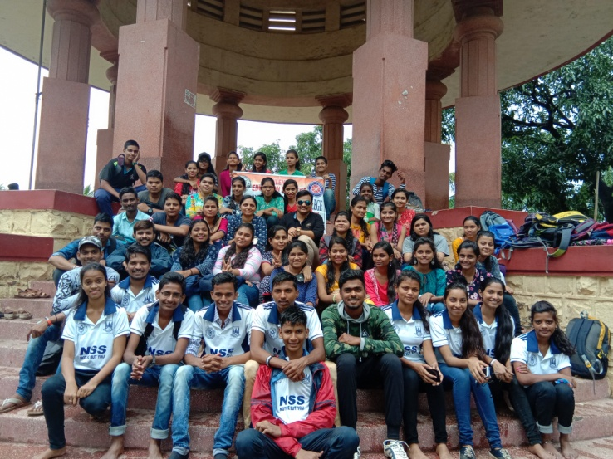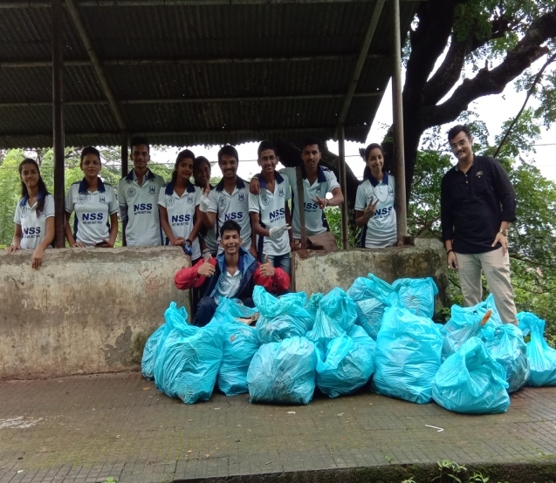
The NSS Unit and Nature Club has organized a ‘Nature Trail’ and Cleanliness Drive at Sanjay Gandhi National Park Borivali on 18th August, 2018. Mrs. Vidya Mundale was the expert and guide throughout the trail. More than fifity volunteers participated in the activity. The entire areas around the toy train was cleaned. More than 20bags of garbage was cleaned. The students were proud to be a part of the ‘Swacchha Bharat Abhiyan’ Movement.

- CLEANLINESS DRIVE IN COLLEGE CAMPUS
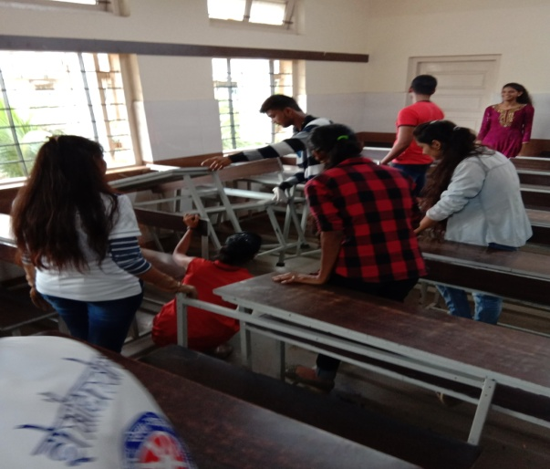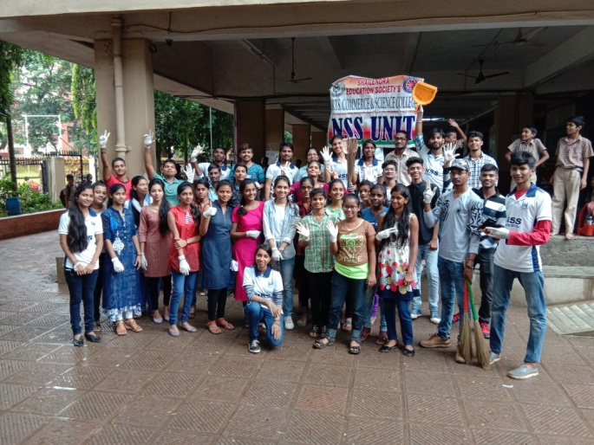
The NSS Unit had organized a cleanliness drive in the college on 16th August 2018. Around 45 students cleaned the college and the surroundings. Classrooms, campus and the ground were cleaned by the students.

- DISTRIBUTION OF 2000 PAPER BAGS ON ANTI PLASTIC DAY – 8TH SEPTEMBER 2018.
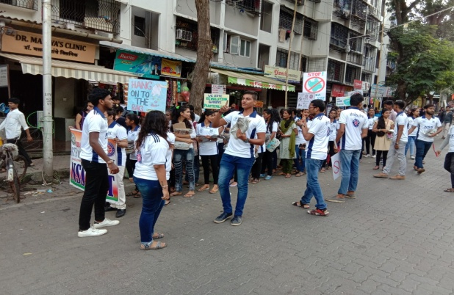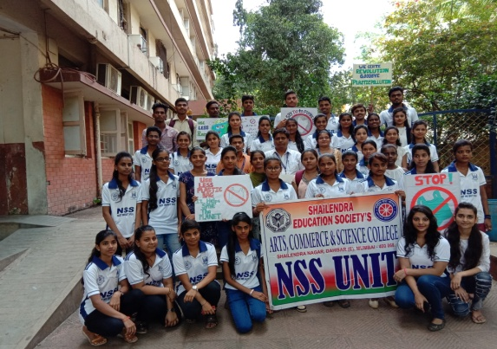
8th September was celebrated as the NSS Anti Plastic Day. An awareness rally was organized by the unit and a total of 2000 Paper bags were made by the volunteers and distributed by them to fruit sellers, shop keepers and other local vendors.

- GUEST LECTURE ON SECULARISM AND DEMOCRACY BY ANUBHAV MUMBAI

The NSS Unit and HPSA of our college had organized a guest lecture with Anubhav Mumbai in order to develop a sense of civil awareness and inculcation of political values among students. Mr. Sandesh Lalge described in great detail about true awareness of political concepts and going beyond mere theoretical and conceptual understandings. The workshop’s importance lies in the fact that these students are on the verge of entering into its active role as citizens of our nation. The workshop will certainly help in making them better citizens in the near future.

- GUEST LECTURE ON GENDER JUSTICE BY ANUBHAV MUMBAI
The NSS Unit had organized a guest lecture with Anubhav Mumbai in order to develop a sense of civil awareness and inculcation of political values among students. Mr. Santosh Mekahle described in great detail how there is an inbuilt imbalance in the gender power structure of our country. He also emphasized on how this imbalance can be eliminated and the condition of the women folk be improved.

- ROAD SAFETY WORKSHOP CONDUCTED BY UNITED WAY NGO
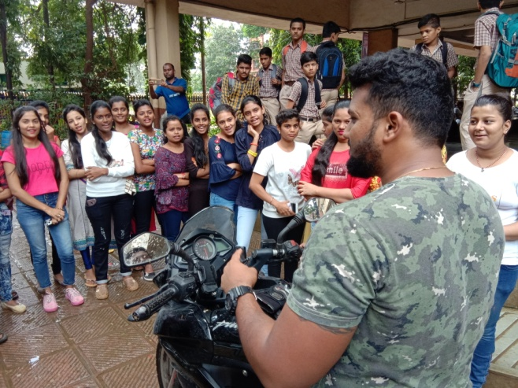
The NSS volunteers of Shailendra Degree College participated in a workshop regarding "Road Safety" organized by the NGO "United Way” in the college. Students were made aware of road safety through PPT presentation regarding road safety measures and given assessment test by providing tablets to each student. They were also given practical on-field demonstration of bike parts and practical riding skills. Around 60 NSS volunteers took part in this activity. There also was a one of its kind, ‘On-wheels stimulator’ for assessment of the driving skills of our students who had a driving licence. It certainly went a long way in making our students safe riders.

- YUVA MAHITI DOOT PROGRAMME UNDER DEPARTMENT OF INFORMATION AND PUBLIC RELATIONS (DGIPR).
The Yuva Mahiti Doot Progragramme had been initiated with the collaboration of UNESCO, Government of Maharashtra and the NSS Cell. More than 30 students had registered on the Yuva Mahiti Doot Application. The students will visit and inform 50 households each about the various government schemes for the weaker sections of the society.

- CELEBRATION OF ‘BHAJAN SANDHYA ’ GANDHI JAYANTI AT GATEWAY OF INDIA ON 2ND OCOTOBER 2018.
Around 15 students had visited the Celebration of 150th Centenary Year of Gandhiji’s birth anniversary. More than 600 students from the University of Mumbai attended it and the Vice Chancellor, Mr. Suhas Pednekar was the Chief Guest for the event.

- DANOTSAV WORK WITH GOONJ ORGANIZATION
12 Volunteers of our NSS Unit participated with the ‘GOONJ’ NGO for Danotsav Event. They gave their service by collecting donations in cash and kind from the areas of Goregaon to Bhayander. The students completed a total of 16 Hrs in the activity.

- CELEBRATION OF SURGICAL STRIKE DAY ON 29TH SEPTEMBER 2018

The NSS Unit celebrated the Surgical Strike Day on 29th September 2018 by visiting the Neighbouring Commando Unit of Mumbai Police. More than 20 students gave a greeting of gratitiude to the commandoes individuatally. It was a wonderful experience for the students to listen directly from the soldiers who give us the peaceful environment in which we live.

We wish to conduct many activities for the students this year and are hopeful about the enthusiastic participation from them

